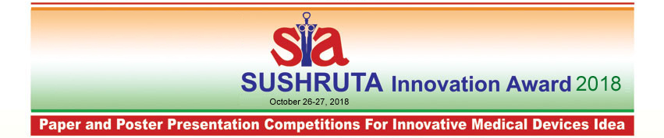
Application Form For Paper Presentation Competition (Details At: http://www.imdiconferences.com/student_application_form_2018.pdf )

* | First Name:
* | Last Name:
* | Date of Birth:
* | Gender:
* | Department:
* | University:
* | College:
* | Address:
* | Address: | City: | Pin Code:
* | Address: | State:
* | E-mail:
* | Phone Numbers | Telephone: | Mobile:
* | Title:
* | Research Guide / Supervisor | Name:
* | Research Guide / Supervisor | Designation:
* | Research Guide / Supervisor | Contact Number:
* | Research Guide / Supervisor | E-mail
Note: All student registering for the competition has to compulsory fill the student delegate form.
- Please attach following the following:
- Title of the Project & Abstract of Project (not more than 500 word)
- Entries (in the soft copy by email as well as hard copies) both received on or before October 10th, 2018 will only be considered valid.
We hereby confirm our participation for Paper Presentation on Sushruta Innovation Award 2018. We have read the rule and guidelines of the competition and agree to the same. The judgment made by the evaluating committee would be binding on us.

(Signature of the applicant - student) (Signature of the Research Guide / Supervisor with college / institute stamp)
Date:
Place:
Encl: Title & Project Abstract
Please send the above registration form duly filled to:
Conference Secretariat
C/o. Classic Computer Services
B-4 Mandir Appt., Opp. P&T Colony, Jodhpur Char-Rasta, Satellite Road, Ahmedabad- 380 015. India. Phone : +91 79 26740611; Telefax : +91 79 26754867 M : +91 9825457563
www.imdiconferences.com • Email: mpds00@vsnl.com / dlpandya@gmail.com
N.B.: In case of group of more than one students, write details about the group coordinator. Give details about the other group members in a separate sheet of paper.

